Modeling of AF-130 PMSM with vector control MCU PM100DZ

Punit Purohit

Mechanical engineering student (GD7198)

INTRODUCTION

This project intends to model the performance of Evo-electric ‘AF-130’ Permanent Magnet Synchronous Motor which is controlled using a Rinehart motion systems- AC motor Controller- ‘PM100DZ’.

For this project, we started with collecting all the data that is available about the motor and the controller which will help in providing values to various variables in modelling. we used the research paper by Pragasen Pillay and Ramu Krishnan on ‘Modeling, Simulation, and Analysis of Permanent-Magnet Motor Drives’ to understand the modelling of the PMSM and to validate the existing Simscape blocks for modelling PMSM and vector control.

Due to time constrains the modelling of the cooling system was simplified to a basic convective heat transfer model using the understanding from previous engineering courses and referring to the book on Heat and mass transfer by R.K. Rajput.

The Dynamic motor model and thermal model were them fine-tuned with Parameter estimation using available experimental data. There were still some variation between the experimental and simulated data which was explored to find the cause for the variation.

EVO-Electric AF-130 motor

The AF-130 electric motor is a three-phase permanent magnet motor that uses proprietary axial flux technology.

|  |  |
| --- | --- |
| Specifications | |
| Type | PM Synchronous -Axial Flux |
| Maximum Speed | 8000 rpm |
| Nominal Torque | 145 Nm |
| Peak Torque (for up to 60s) | 250Nm |
| Peak Torque (for up to 20s) | 350Nm |
| Nominal Output Power | 64kW |
| Peak Output Power (for up to 60s) | 100kW |
| Peak Output Power (for up to 20s) | 140kW |
| Torque Density | 11.5Nm/kg |
| Power Density | 4.6kW/kg |
| Peak Efficiency | 95.10% |
| Coolant Medium | Water/Glycol (50/50) |
| Coolant Flow Rate | > 8l/min |
| Dimensions | 110 mm (L) x 300 mm (D)at 30.5 kg |

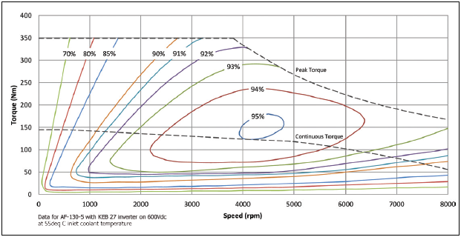

PM100DZ motor controller

The motor controller converts the DC power from the vehicle Energy Storage System to the 3-phase AC required by the motor. The PM100DZ uses the Vector control technology for controlling the torque output of the motor.

|  |  |
| --- | --- |
| Description Value | |
| Short Circuit Protection | Yes |
| Hardware Over-current Protection | Yes |
| Vehicle System Power | 9.. 16VDC (12V Systems) |
| Operating Temperature Range – coolant water – no derating | -40 .. +80ºC |
| Isolation – High-Voltage to Low-Voltage | 1000Vrms |
| Isolation – High-Voltage to Case | 1000Vrms |
| Isolation – Low-Voltage to Case | 50V |
| Operating Temperature Range – coolant water – derated output power | -40.. +105ºC |
| Non-Operating Temperature | -40 .. +115ºC |
| Storage Temperature | -55 .. +105ºC |
| Coolant Type | 50/50 EGW |
| Coolant Flow Rate | 8 – 12 LPM |
| Coolant Pressure Drop | 0.2 bar for PM100xx |
| Maximum Coolant Pressure (above ambient) | 1.4 bar |
| Operating Shock (ISO 16750-3, Test 4.2.2.2) | 500 m/s2 (50g) |
| Operating Vibration (ISO 16750-3, 4.1.2.4 Test IV) | 27.8 m/s2 (3grms) |
| Environmental Protection Class (see ISO 20653) | IP6K9K |

Modeling of PMSM

The PMSM and SM both have similar stator and wound rotor respectively, the induced currents in the rotor of PMSM are negligible and both produce similar back EMF. Hence the mathematical model of a PMSM is similar to that of the wound rotor. therefore, the d-q equations of the PMSM are:

Where,

νd and νq are q and d axis voltage, iq and id are q and d axis stator current, id and iq are the d, q axis stator currents, Ld and Lq, are the d, q axis inductances, λd and λq, are the d, q axis stator flux linkages, while R and ωs, are the stator resistance and inverter frequency, respectively. λaf is the flux linkage due to the rotor magnets linking the stator. The electric torque is

And the equation of motor dynamics is

P is the number of pole pairs, TL is the load torque, B is the damping coefficient, ωr, is the rotor speed, and J is the moment of inertia.

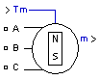SIMSCAPE MODELING – Simscape comes with a general model of the PMSM machines here are a few details about the Simscape PMSM block:

The Permanent Magnet Synchronous Machine block operates in either generator or motor mode. The mode of operation is dictated by the sign of the mechanical torque (positive for motor mode, negative for generator mode).

The block has the options to opt for either sinusoidal or Trapezoidal flux since Pragasen Pillay and Ramu Krishnan have assumed a sinusoidal flux we will be going with that option. The equations driving this block are:

Here, Lq, Ld are q and d axis inductances, R is Resistance of the stator windings.iq, id are q and d axis currents. vq, vd are q and d axis voltages. ωm is Angular velocity of the rotor. λ is Amplitude of the flux induced by the permanent magnets of the rotor in the stator phases. p is Number of pole pairs and Te is Electromagnetic torque

And the dynamic motor equation

Where J is combined Inertia and rotor load, F is Viscous friction, θ is rotor angle position ωm is Angular velocity of the rotor, Tm is shaft mechanocal torque and Tf is shaft static friction Torque

Comparing the two models we can see that the core concept behind the model in the research paper and the model in the simscape is same although the assumption in the paper reffered are more and hence we conclude we can use the PMSM block and we can use a simplier version by neglecting some variables.

Vector control of a PMSM

Vector control is normally used in ac machines to convert them, performancewise, into equivalent separately excited dc machines which have highly desirable control characteristics.

Wikipedia explains vector control as “a variable-frequency drive (VFD) control method in which the stator currents of a three-phase AC electric motor are identified as two orthogonal components that can be visualized with a vector. One component defines the magnetic flux of the motor, the other the torque. The control system of the drive calculates the corresponding current component references from the flux and torque references given by the drive's speed control.”.

Figure 1 Phase diagram of vector control

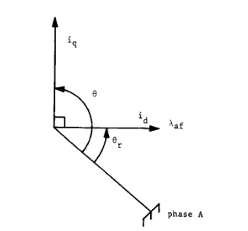The rotor flux linkage revolves at rotor speed ωr and is positioned away from a stationary reference by the rotor angular position, given by

where t is the time. If id is forced to be zero, then

Since the magnetic flux is a constant, the torque is directly proportinal to the q axis current. This is represented as

Where

Torque equation is similar to that of a seperately excited DC motor.

SIMSCAPE MODEL-

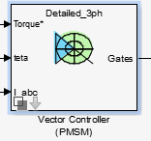Simscape has a vector control PMSM block which is shown below

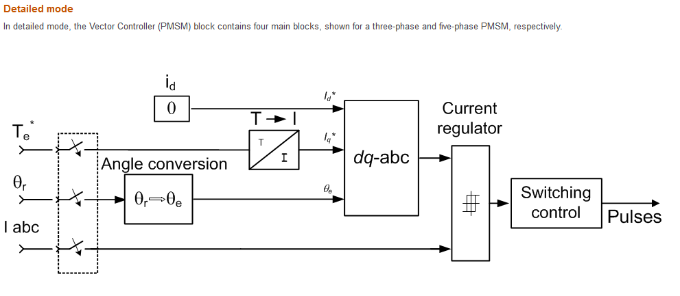

This block uses the vector control logic for PMSM and we will be using this to model our complete dynamics.

Modeling USING SIMSCAPE BLOCK

Since many variable for modeling the motor are unknown we will create single value variables for those parameters so that we can utilize them for parameters estimation. A step by step modeling guide is not needed as most of the blocks are present in Simscape understanding the functionality and parameter estimation is given focus.

VECTOR CONTROL MODEL

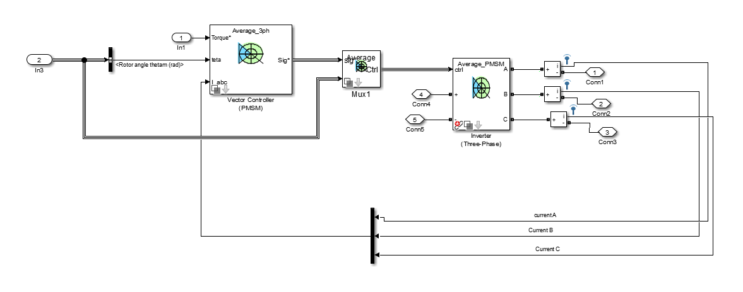

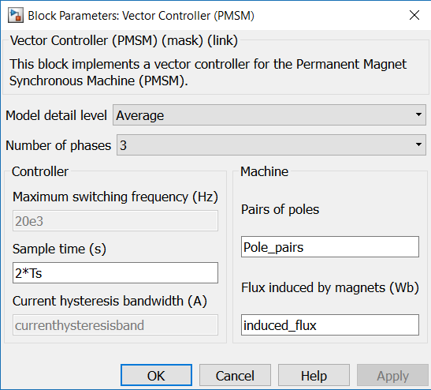Vector Control (PMSM) Block Values

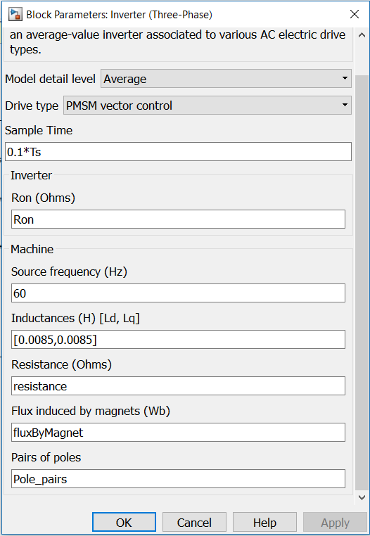THREE PHASE INVERTER BLOCK PARAMETERS:

The block shown above are easy already present in Simulink and you are just required to understand the functioning of the block which will help in creating the proper circuit.

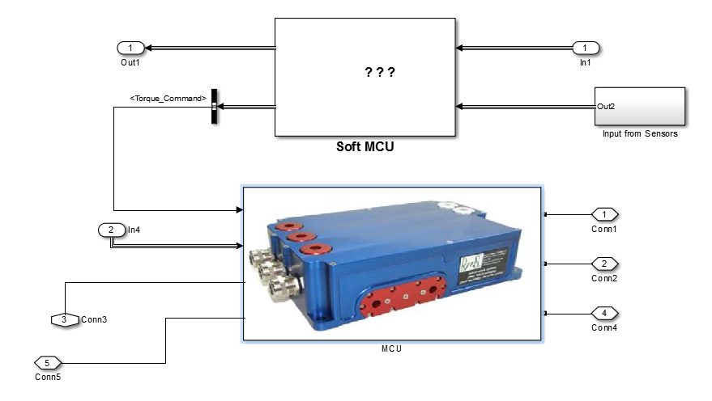

SUBSYSTEM SOFT ECU:

Subsystem Soft ECU receives the signals from HCU and sensors and calculates the desired action to get the required torque. This subsystem is imported from the provided SOFT MCU model because the provided model in sufficient for our requirements.

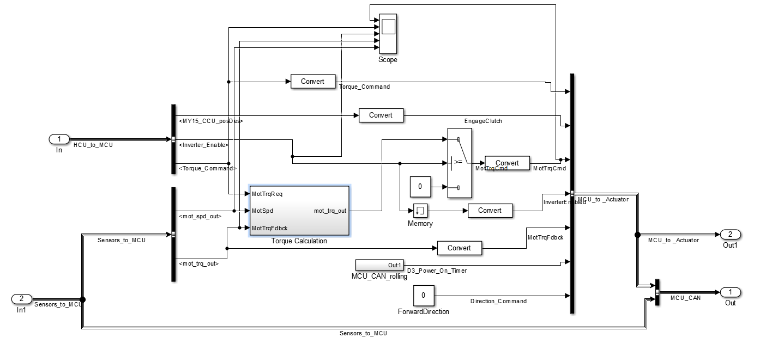

MOTOR MODEL

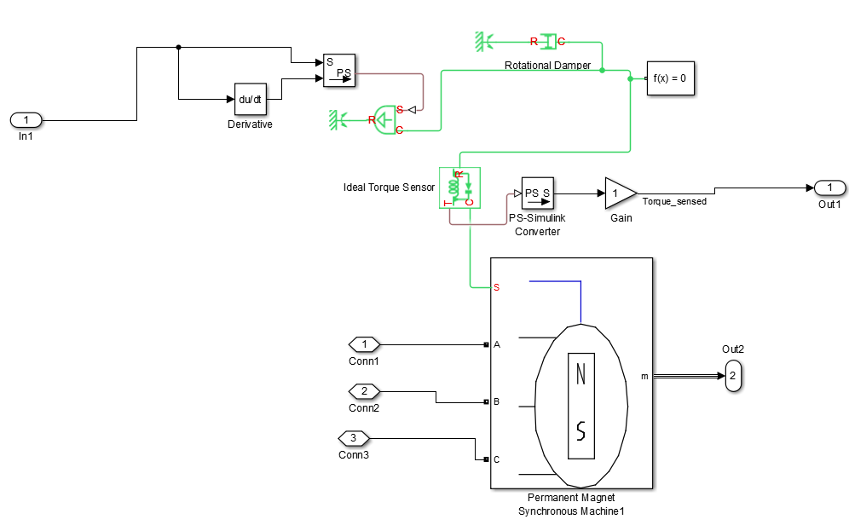

MOTOR PARAMETERS

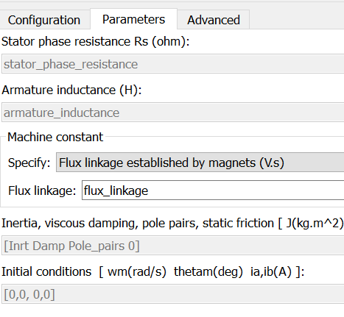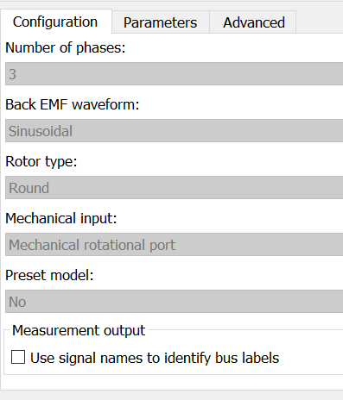

Complete Model

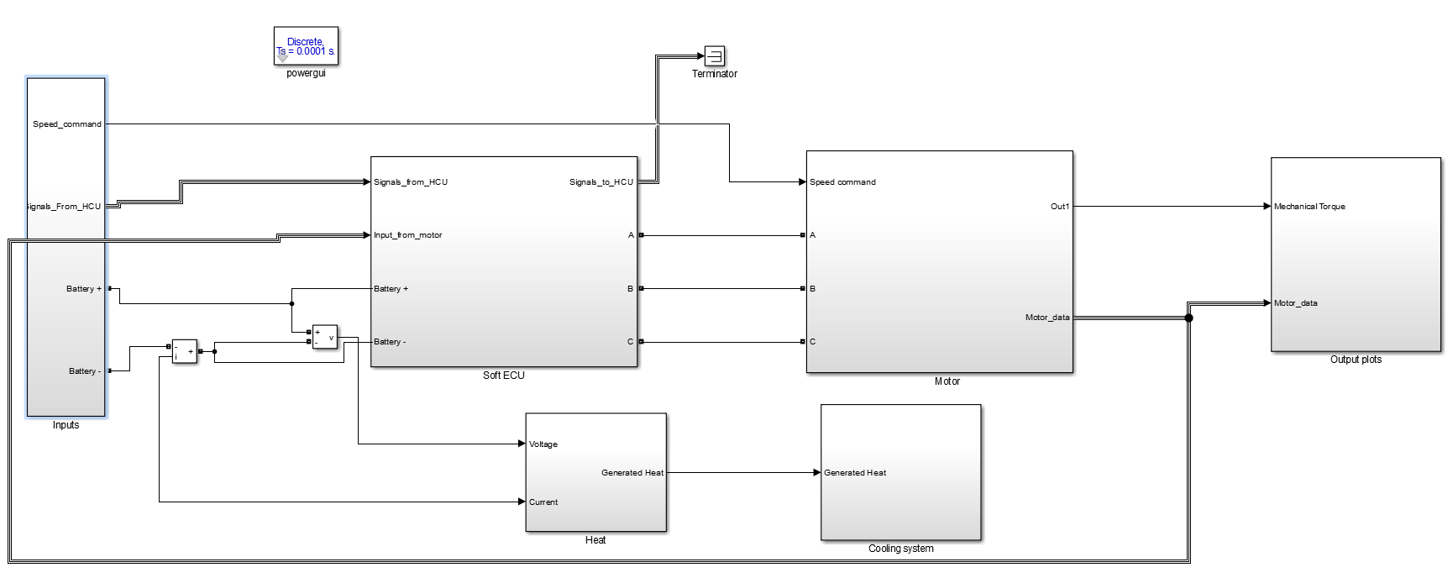

This block uses the vector control logic for PMSM and we will be using this to model our complete dynamics.

thermal modeling

The heat generated is determined by the difference between the electric power from Battery and the mechanical power generated hence this heat accounts for heat generated in MCU and motor both.

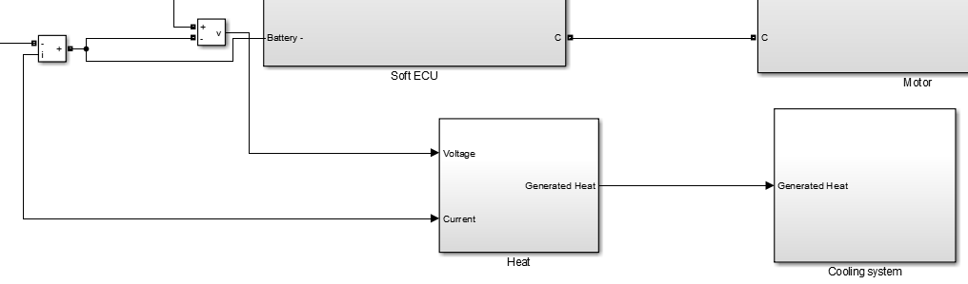

Inside Subsystem heat :-

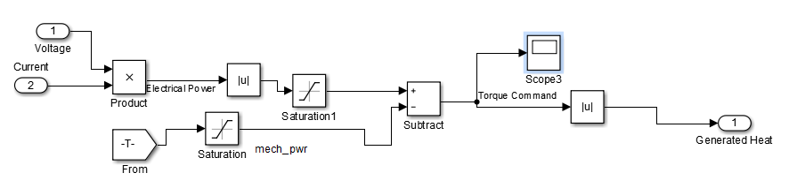

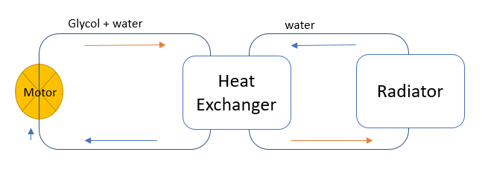 The cooling model has been simplified because of time constrain and because of having an already complex motor model. The figure below shows a conceptual image of logic.

Figure 2 Cooling system

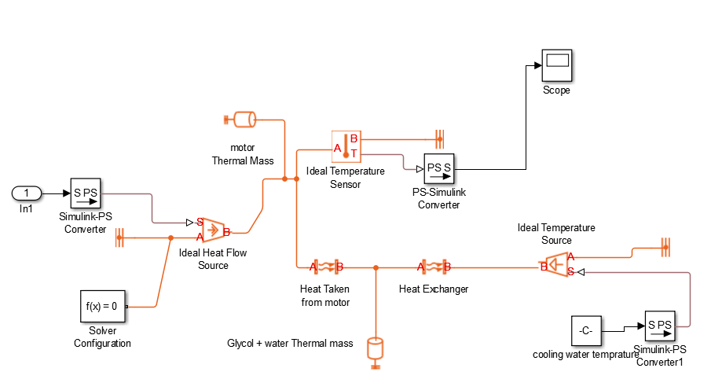This logic is implemented using simple convective heat transfer block where heat exchange is taking place.

CONTROL OF COOLING:

The pressure drop and the flow rate is provided in the motor specification this can be further altered to get desired cooling performance. The control of cooling and pumps is handled by HCU.

INPUTS SUBSYSTEM

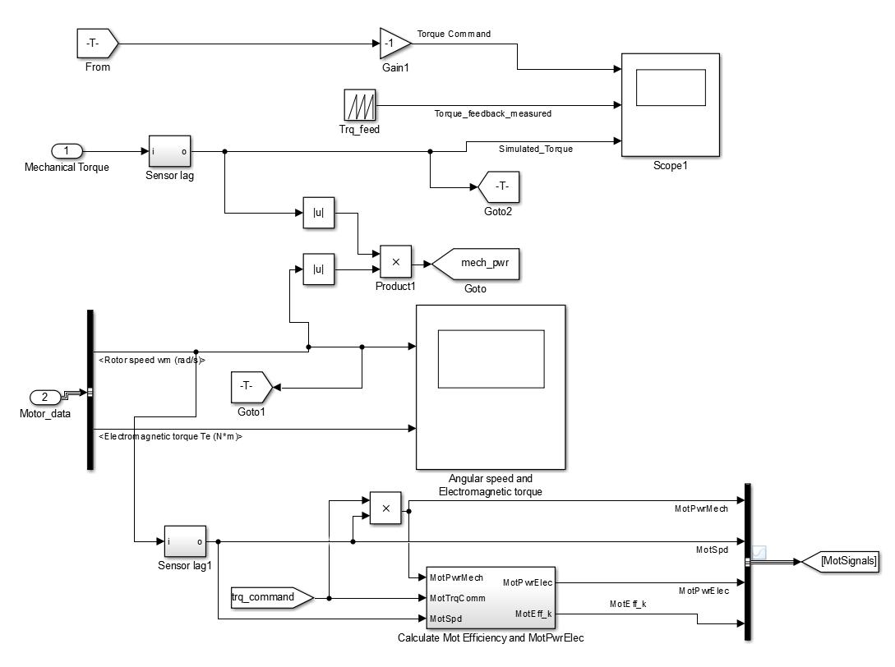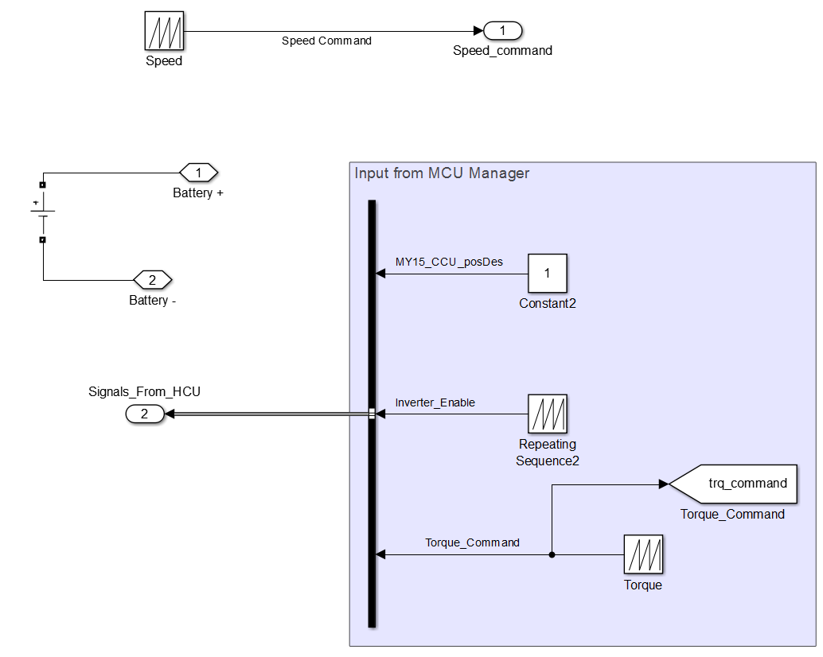OUTPUT PLOTS SUBSYSTEM

Parameter Estimation

Initialize the following variables with values somewhere around the values provided. These provided values are final values obtained after parameter estimation.

|  |  |  |  |
| --- | --- | --- | --- |
| Ts | 1.00E-05 | resistance | 0.11607 |
| stator_phase_resistance | 0.0490392 | fluxByMagnet | 0.17491 |
| armature_inductance | 6.32E-04 | temp_amb | 300 |
| flux_linkage | 0.17216 | coolant_cp | 200.07 |
| Pole_pairs | 3 | coolant_mass | 2.2147 |
| induced_flux | 0.17197 | hac | 9.2743 |
| currenthysteresisband | 0.1 | hcm | 35.286 |
| Snubberresisrance | 1.00E+04 | htArea | 0.2 |
| Ron | 7.83E-06 | motor_cp | 12.5 |
| Inrt | 2.50E-04 | radiator_area | 2.3951 |
| Damp | 4.18E-04 | motor_mass | 30 |
| battery_Voltage | 390.4254 |  |  |

For parameter estimation open the parameter estimation panel and click on new experiment.

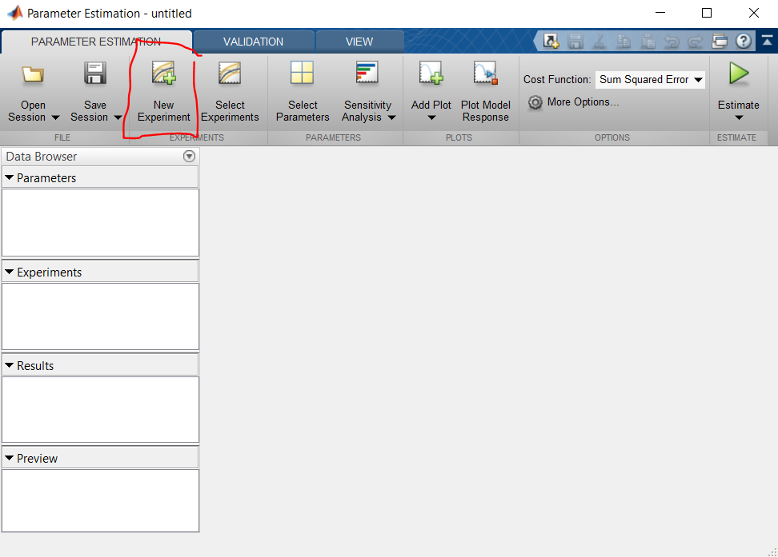

In the popped-up window click “select measures output signal” signal then go to the output plots subsystem and select torque sensed signal.

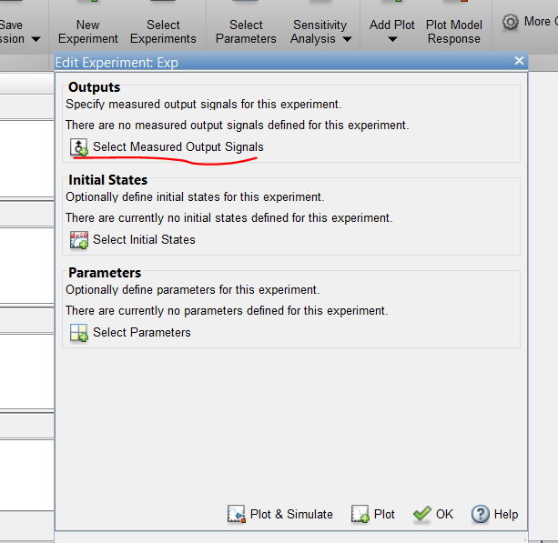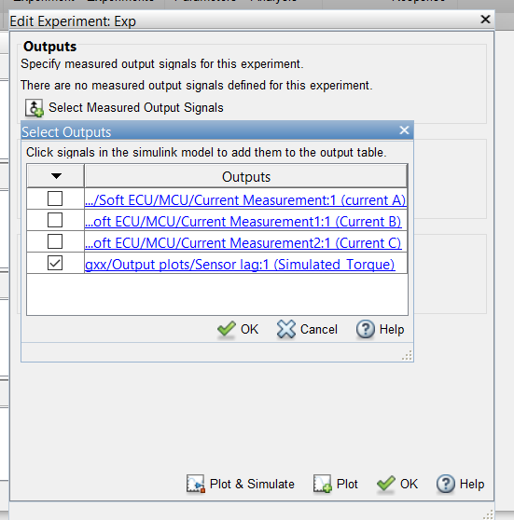

Click ok in the popup window than below the signal value enter the variable name of time and torque feedback from the test data which you would have created earlier.

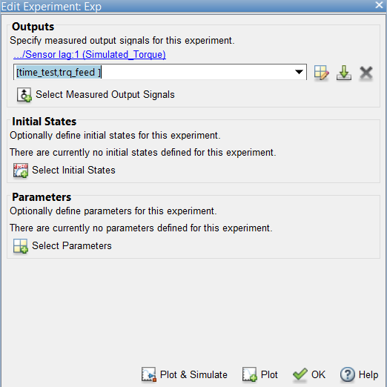

Then, click on select parameters and the select all variables that affect motor torque output and click ok.

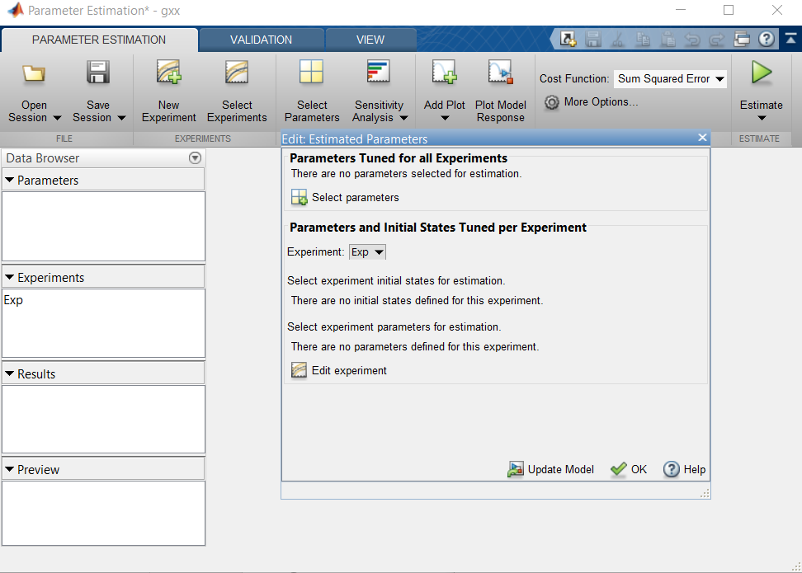

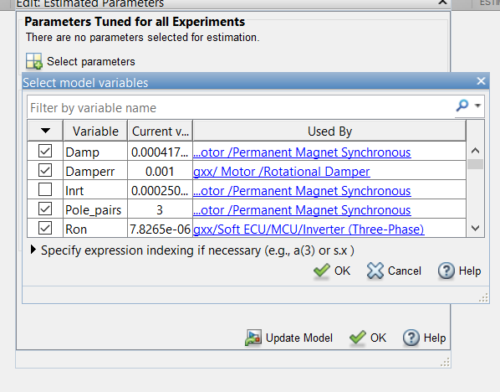

In plots create an experimental plot and then click the plot simulation data button this will show the initial simulated output and measured data. Then click on Estimate and the process would start

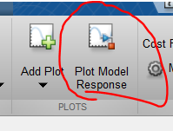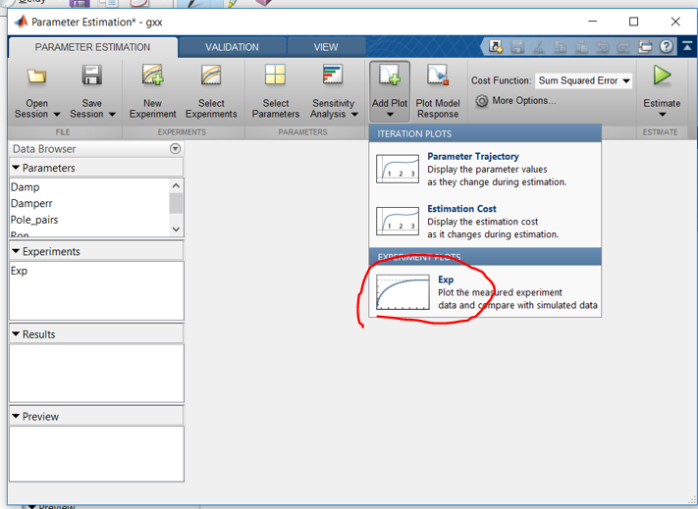

the experimental data is too large for parameter estimation as it would take huge amount of time to estimate the data using the complete data therefore the a 2 sec slot of data was taken to estimate parameter then using the estimated parameter the simulation for ran for the full input data to verify the parameters.

The parameter estimation was done separately for motor dynamics and thermal to improve performance.

Here are the results of parameter estimation :

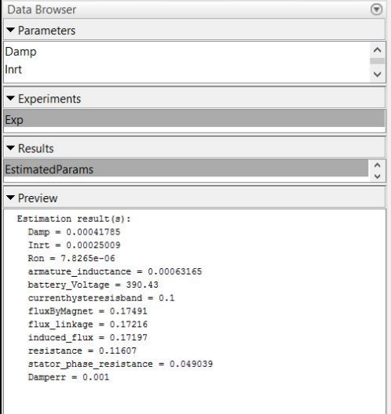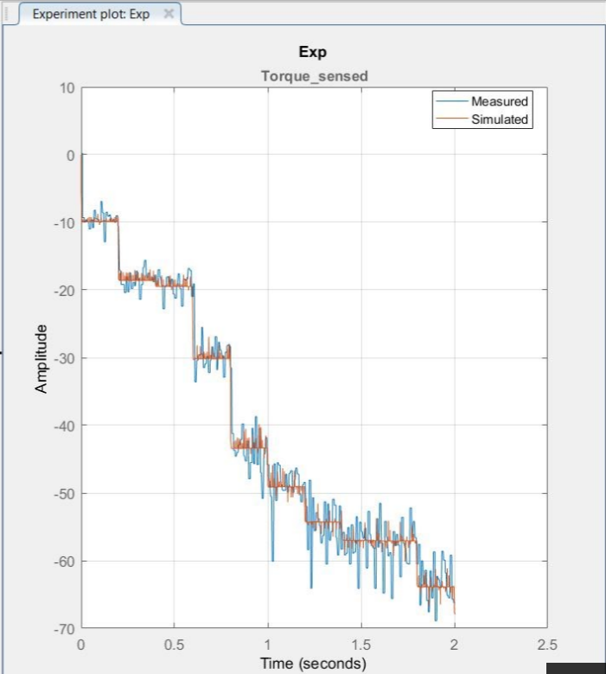

Thermal Model Parameter Estimation:

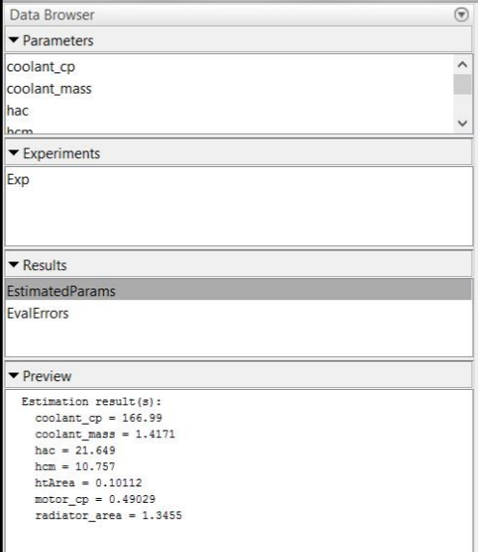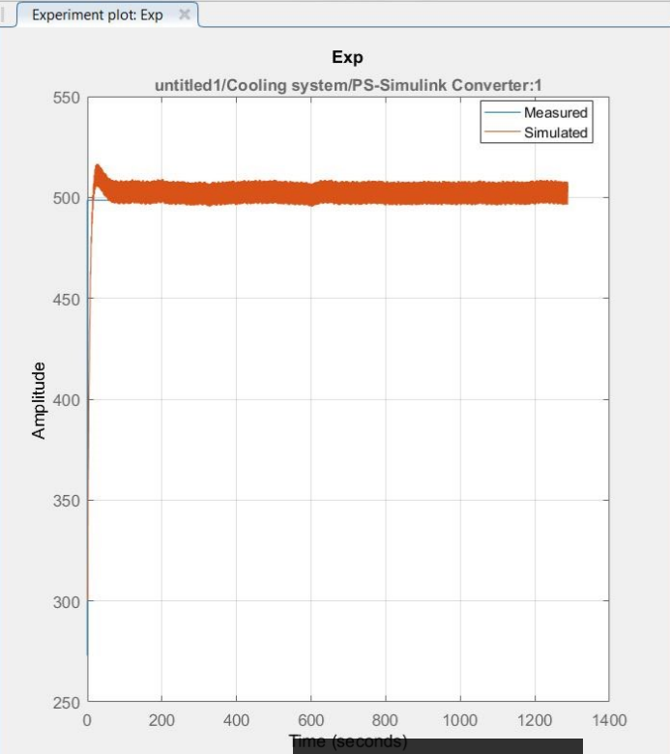

Simulation and Results

Due to low Simulation speed it was very difficult to simulate the test for whole 1288 secs therefore, for testing and simulation a 76 sec of data clip was taken from the test data and than the result obtained.

Here are the plots obtained:

Torque:

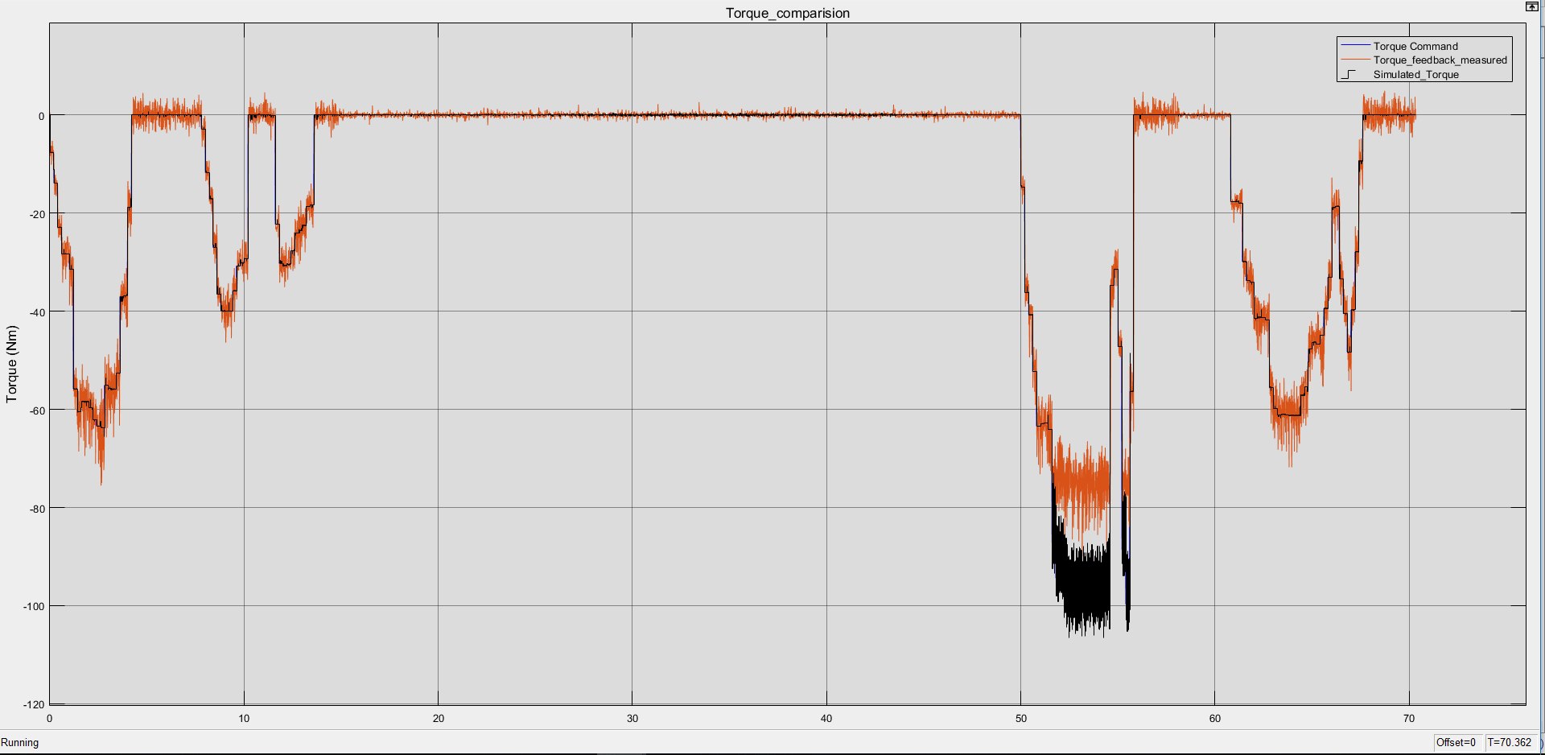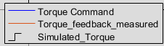

ROTOR SPEED AND ELECTROMAGNETIC TORQUE

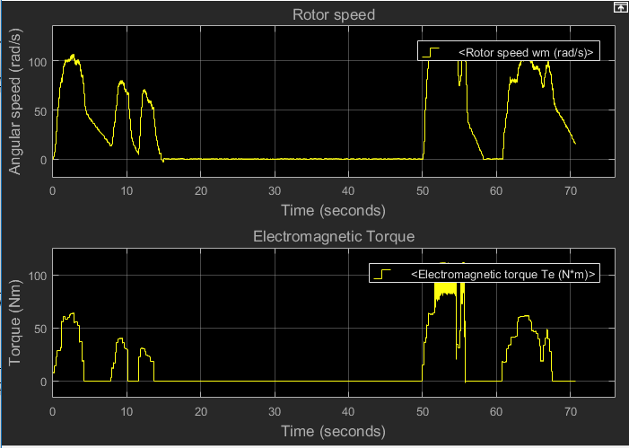

TEMPERATURE

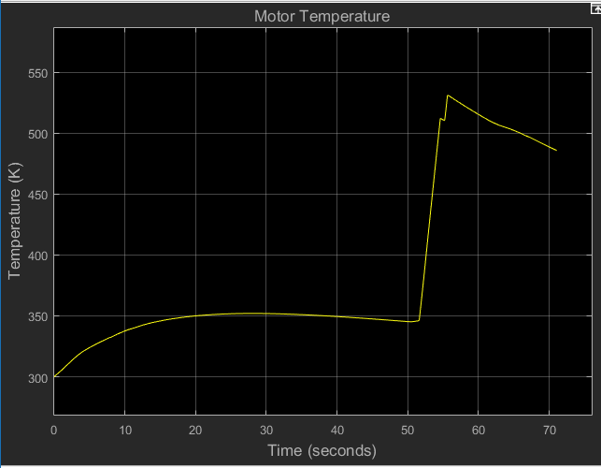

Conclusion

There are two major discrepancy in the test data let’s discuss them one by one.

When the initial torque command is fired, the motor is unable to meet the torque demand and just provides 20% of the torque demand. There are two possibilities for this. One, a mistake in setup but it seems unlikely as the later torque demand is successfully met, another possible reason for this could be that “Damper windings were used to run the machine up to speed on induction motor action with the machine pulling into synchronism by a combination of the reluctance and synchronous motor torques provided by the magnet. During the startup, the magnet exerts a braking torque that opposes the induction-motor-type torque provided by the damper windings.”[1]

Second abnormality in the experimental data is the temperature measure at motor the value remains at 0 deg C for few mili- seconds and then jumps to 225.6 deg C.

The initial 0 values might be due to the response time of the sensor which means that the system was always at 225.6 deg C. the flow of heat occurs due to the difference in temperature of the two bodies first. The motor remaining at 225.6 deg C throughout experiment that means there is a perfect sync between the coolant flowrate and torque demand and hence all heat produced is taken by the coolant instantaneously. Which seems highly unlikely which forces the conclusion that there is some mistake in the recorded data although a we have developed a cooling system which keeps the motor within safe operating temperature range this model can be modified to fit true data when available.

Otherwise model is very close to the actual performance of the motor and is ready to be used as a part of more complex systems.

Although model runs slow the simulation speed can be increased by increasing the step size(Ts) in MATLAB to suit the requirements although the accuracy would deteriorate with increasing step size. Ts = 1e-5 gives the best results, but the model is set to Ts = 1e-4 for better speed;

References

1. Pragasen Pillay and Ramu Krishnan “Modeling, Simulation, and Analysis of Permanent-Magnet Motor Drives ,Part I: The Permanent-Magnet Synchronous Motor Drive”, 1989
2. Bose, B. K. “Modern Power Electronics and AC Drives, NJ” Prentice-Hall, 2002.
3. Y Narkhede "Simscape modeling of motor generator unit component for hybrid electric vehicle" smartech.gatech.edu, 2016.
4. R.K. Rajput “Heat & Mass Transfer” S. Chand Limited, 2007.
5. AF‐130 Spec Sheet V1.1.pdf
6. AF‐130‐Tech‐Sheet‐V13.pdf
7. AF130‐4 plots.pdf.
8. AF 130  AF 230 Integration Guide R2 ‐ Mar 2015.pdf
9. AF130‐4_data.xlsx
10. PMxxx Datasheet 01052012.pdf
11. EMachine_Test_Data.csv
12. https://www.mathworks.com/discovery/parameter‐estimation.html

CONTACT

Punit Purohit, Mechanical Engineer, Student – Wayne State University

Access ID: GD7198, Email : punit.purohit@wayne.edu